**WEEK 5 and 6 output documentation**



**Documentation**

Fundamentals of Data Science

UFCFK1-15-0

**Submitted by:**

**Name:** Shrawan Budhathoki

**Section:** I

**Student ID:** 25024656

**Question 1**

This program is used to read the content of a file (“student.csv”) and print it.

**Input and output**

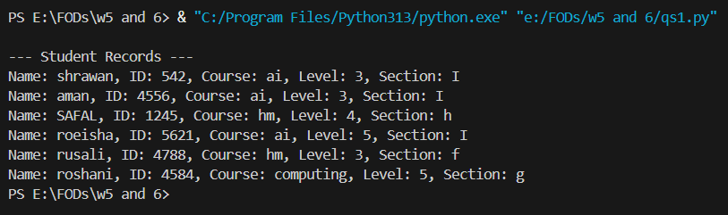

**Question 2**

This program take input from the user about student details and adds it to the existing (“student.csv”) file.

**Input and output**

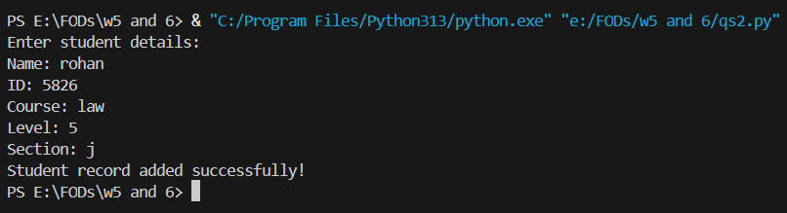

**Question 3**

This program takes a list of input from the user, performs addition, subtraction and division and saves its data into a file. The user can choose when to exit the program and output is printed at last in a proper format alongside date and time. (Date and Time module have also been imported)

**Input and output**

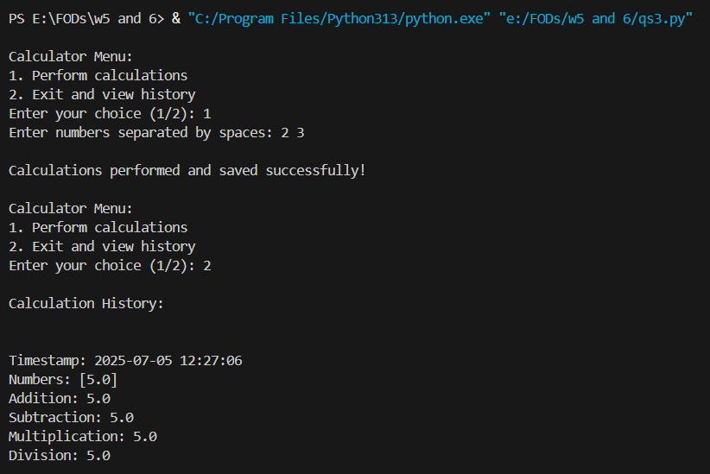

**Question 4**

This program asks the user to input two filenames. The program then copies the content of first file to second file. An error is displayed if the file doesn’t exist.

**Input and output**

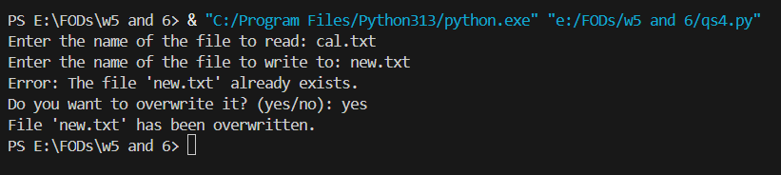

**Question 5**

This program is an object-oriented program which takes input from the user about the student data and prints it at the end.

**Input and output**

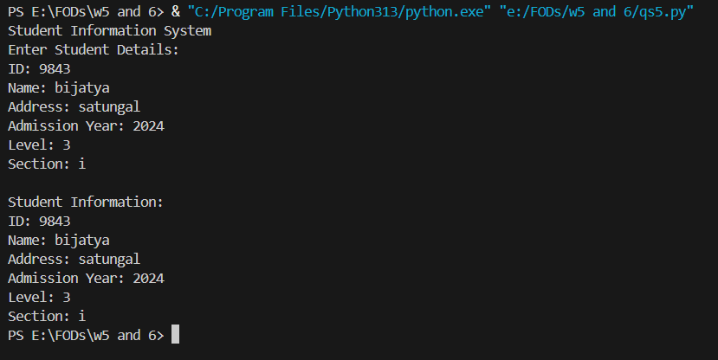

**Question 6**

This program is an object-oriented program which stores various recipes, and the user can add or view existing recipes as per their choice. It’s kind of a menu driven program.

**Input and output**

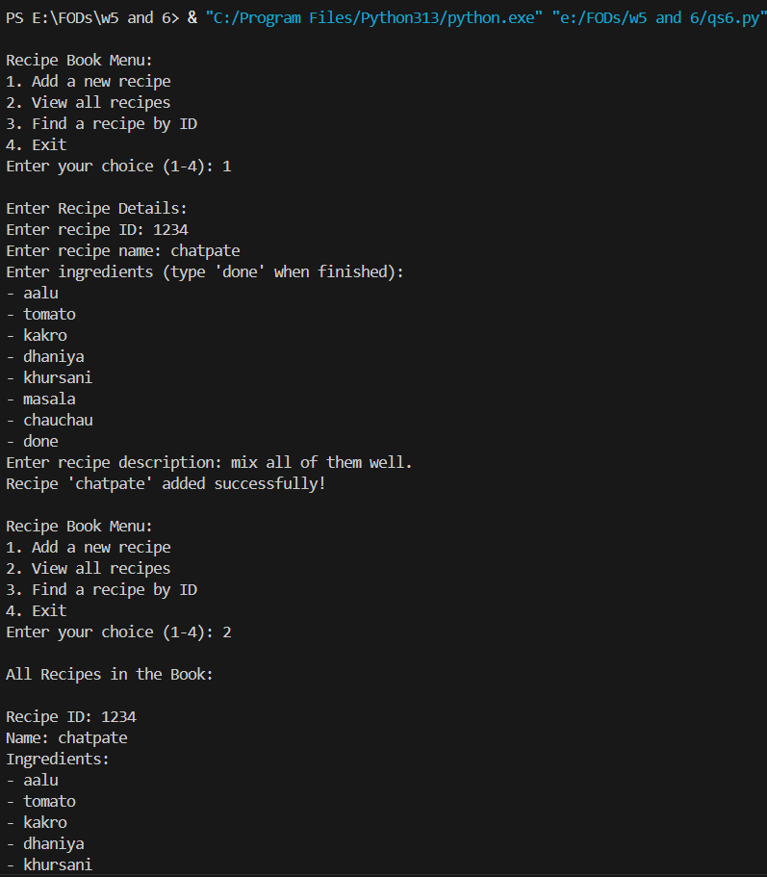

**Question 7**

This program allows the user to see the list of employees and their details. Modules such as csv and try_except have also been used. A menu driven program managing details of various employees

**Input and output**

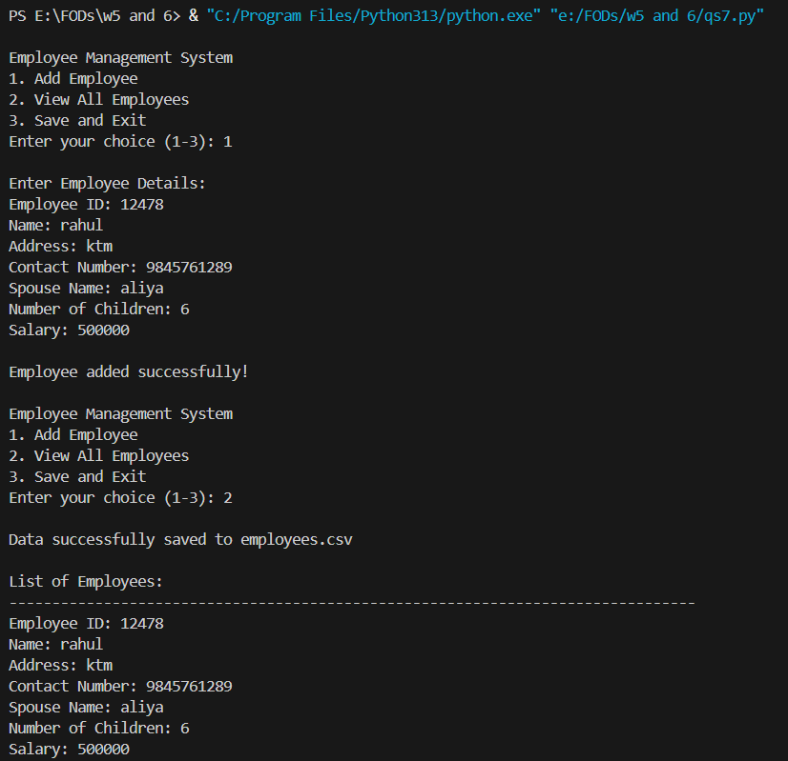

**Question 8**

This program is a basic library management system where the user can publish a book, search and issues a book, using file handling and object orient based code. Menu driven code. A specific function is created to do a specific task.

**Input and output**

